EMB101
Interview of someone’s experience of living through 1971

NAME: Magferah Sultana Samia
ID NO: 22101875
SECTION: 23
SUBMITTED TO: Istiaque Hossain Sir

Title of the interview:
“ORAL HISTORY WITH MD. OBAIDULLAH KHAN”,
2023, March 16

Author: Khan, MD. Obaidullah,1951-, and Samia, Magferah Sultana
Author (no collectors): Khan, MD. Obaidullah,1951-, and Samia, Magferah Sultana
Collectors: Khan, MD. Obaidullah,1951-, and Samia, Magferah Sultana

My thought on the Liberation war and the details of the interviewee:

Our Liberation War of 1971 is a testament to the courage, determination, and
sacrifice of the Bangladeshi people, despite the odds. As a student and a citizen of
this country, I can't help but be filled with wonder and reverence for Bangladesh
Liberation War of 1971. It is difficult to understand fully the anxiety and terror that
must have filled the atmosphere in those days as the country fought to free itself
from Pakistan's tyrannical rule. However, the bravery and resilience of our people
in the face of such adversity is a reminder that, no matter how dark the night may
seem, there is always hope for a brighter tomorrow. Therefore, we must remember
the sacrifices and teaching and try and apply them in our daily life. The person whom
I have taken the interview on liberation war is Md. Obaidulllah Khan.
He was a freedom fighter under the Guerilla forces who fought at Dohar thana,
Nawabganj thana, and its surrounding area, in 2 no sector of Bangladesh.
After the independence he did business, and now passes him time to retirement. He
lives in Shiddheswari, Ramna, Dhaka-1217. My family is one of his tenants in his
own building. So, my relationship with the interviewee is building owner-renter. I
address him as “Nanavaia” and I know him for around five years. From time to time,
I have heard about his experience through his wife or daughter and after seeing
several years, I have come to know that he is really an honest man with a diligent
personality. That is why I preferred him for my interview as I believed he will give
correct information and evidence.

Description of the Interview:
Md. Obaidullah Khan was born at Narisha Khalpar village in Dohar Thana of Dhaka district in 1951 in a prestigious and religious family. His father, Abdul Malek Khan was a village- head (member) of the Narisha, and his mother, Mst. Gollapjan was the housewife. He has four brothers and three sisters. He is the fourth among them. He is 72 years old. His father was famous for his honesty and piousness and this proved to be a valuable asset to Obaidullah during the liberation war. He remembers that his father used to sit with elderly people in the villages and distribute the reliefs equally. Obaidullah was a student at Jagannath College (Jagannath University) in March 1971. At that time Jagannath was very popular. When he learned of the massacre of March 25 on 26th March, he and the other 16000 students and staff members of the college were filled with rage and a burning desire to reach the Bangabhaban as quickly as possible. He arrived at his house in Narisha village, and after a few days, he joined a group of liberation fighters there under the command of retired Captain Abdul Halim Choudhury (former govt. minister). They were trained locally by the Bengali officers who worked in Pak Army before the war started. They mainly used to throw bombs, and grenades and blow out Pakistani camps and tanks at night. As Obaidullah fought in his own region, he often went home. One day when he was at home, some razakars along with the Pakistani soldiers came to their house and asked his father, “Obaidullah kaha? (Urdu)”. When Obaidullah's father, Abdul Malek, approached them to speak, they learned that he was a Hajee (a pilgrim). Upon discovering this, the Pakistani soldiers were grateful and expressed their happiness. They even instructed him to contact them at their camp if he needs anything. Obaidullah was protected in this way, and razakars never physically visited their home. Another memory he shared was one day while battling with Pakistani at Nawabganj thana they entered Bakshanagar village and they caught sight of a pile of dead bodies. Their eyes and hands were tied up. On the same day, he returned home around the afternoon but he found his room is locked from the inner side. His father notified him that about 5 to 6 Hindu unmarried women took shelter at their house, in his room, and forbade him to tell anyone not even his team. At night, they wore black burkas and Obaidullah took them to his younger sister’s house far from the Dohar. Those women remained there safely until independence. When Dhaka was almost independent and free of terror, Obaidullah’s team went to Sadapur village, Nawabganj thana and there they fought with the Pak army face to face. In one operation, he was at the bunker and the distance between Pakistani soldiers and them was around 500 meters. There, Obaidullah was injured by a bullet in the finger of his left leg. When the surrender was announced, he along with other fighters entered Dhaka, returned the weapons to the Dhaka university campus, and released a captured Pakistani warship at Padma River to the IWT people. “We were so in joy because the war has ended and now, we can walk everywhere in broad daylight.”, he recounted. He witnessed the deaths of his coworkers throughout the operation and was under extreme pressure, yet everyone remained fierce and brave. Rather than feeling depressed, they actually used to feel happy that their colleague had been able to kill an enemy and had died in the most dignified manner. He finished his honors degree after independence, and after that, he opened a business in Dhaka. After some time had passed, he married Anowara Begum. He now has three daughters and lives contentedly with them as well as his grandchildren. He never took advantage of the facility of quotas (“Muktijuddha Quota”) for her daughters. They gave exams without quota and achieved their goals successfully. For many years, he also refused to accept the freedom fighter allowance (muktijuddha vata) as he believed that he had not fought for his country with the expectation of receiving any rewards or privileges. His love for his country was the sole motivation behind his heroic efforts. Recently, however, he has started taking the allowance and distributing it among the poor. When he was asked about his aspect of wartime and after the war, he answered with emotion that in 1971, all fighters were one, singly determined. “Anyway make the country free, no matter what!” he said. But after the liberation war, he observed some freedom fighters fall for greed, some exploited their position and power which broke his heart. He said – “we didn’t fight for our country for this purpose, we fought so that everybody can have freedom of speech, right to live freely”. In this regard, he wants to convey to the young generation in this country that Bangladesh is not living up to its potential as an independent nation. He advised and encouraged us to grasp our basic origin and how we triumphed. His unwavering hope inspires us to strive for a future where true patriotism reigns supreme.
Evidence regarding the interview:
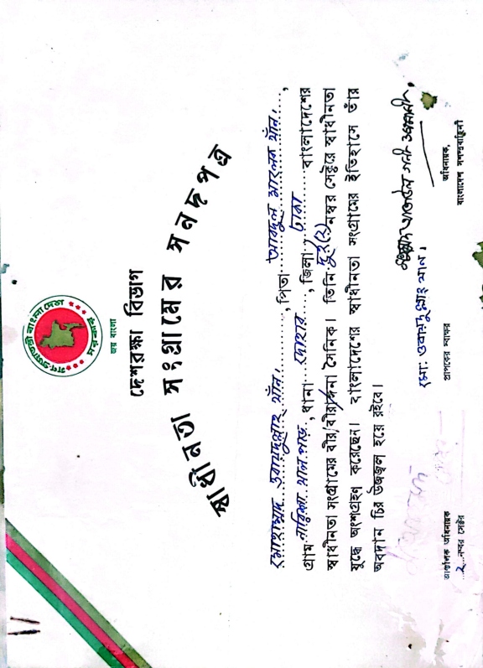
The above interview has helped us to know about the liberation war vividly and has strengthened our resolve to be better citizens of our country. Here the evidence related to the interview is attached below:
- Certificates of the freedom fighter Md. Obaidullah Khan

- Picture of the interviewer with the interviewee

